Compassionate Leave Program
The Compassionate Leave Program is a donated-leave bank benefit for qualifying Administrative (members of URA-AFT); Managerial, Professional, Supervisory, and Confidential (MPSC); and employees who are members of AFSCME Local #888 who are experiencing medical hardship, either personally or in their immediate families.

How to donate days to the compassionate leave program:
Donor must fill out a “Donation to Bank” form:
Donor can do it electronically:
https://hrapps.rutgers.edu/ARS/DonateToBank.aspx

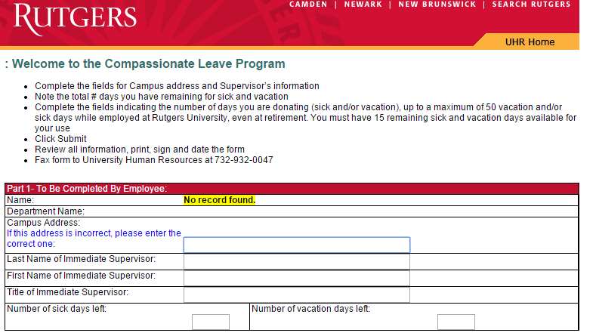
Or Manually:
http://uhr.rutgers.edu//sites/default/files/form_applications/CompassionateLeaveDonation.pdf

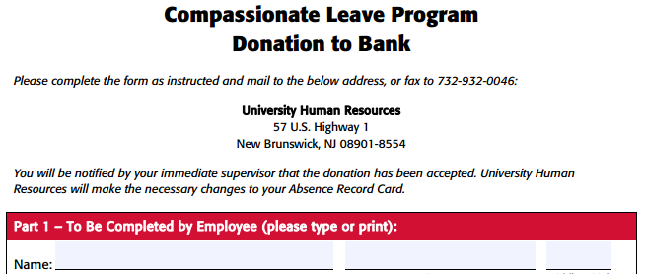

Send the completed form to the University Human Resources.

You cannot donate more than 50 vacation and/or sick days while employed at Rutgers University, even at retirement. Donors are required to maintain a minimum of 15 sick days and 15 vacation days for their own personal use.

All donations are voluntary, confidential, and non-refundable.

Eligibility requirements for Recipients:
- You are eligible to receive donated leave time for an anticipated prolonged absence from work for:
  - Prolonged period of time is defined as 160 continuous hours of missed work by a full-time employee; for part-time employees, a proportionate number of hours based on percent of time worked.
- Care of yourself for a catastrophic health condition
  - Catastrophic illness is defined as a severe condition or combination of conditions that affects the physical or mental health of you or an eligible family member, requires treatment by a licensed practitioner for a prolonged period, and has resulted in a life threatening condition and/or has a major impact on life functions.
- Care of an immediate family member who is suffering from a catastrophic health condition
  - Immediate family member is defined as the employee’s spouse, civil union partner, same-sex sole domestic partner, child, parent, and parent-in-law. The family member must require the employee’s direct care.
    - If you are requesting donated leave time for the care of a same sex sole domestic partner, New Jersey Family Leave and Federal Family and Medical Leave time cannot be requested.
- You must have been employed continuously at the university for one year without a record of prior discipline resulting in suspension or termination
- You must have exhausted all of your available PTO(paid time off) including AL and PH days.
- If you are requesting compassionate time for your own care, you must use donated leave prior to filing through another program. Any eligible programs would commence at the cessation of the donated leave. Programs such as temporary disability, worker’s compensation, and disability retirement.
- Donated leave time awarded will run concurrently with the New Jersey and Federal Family leave acts and will be charged against any leave entitlement. However, you must formally request family leave.
- You may request donated leave time after exhausting all of your available paid leave time, including administrative leave and personal holiday days.
- An employee will receive no more than 30 donated leave days per fiscal year.

Procedures after eligibility:
After meeting the eligibility requirements, employees should complete the request for compassionate leave form: http://uhr.rutgers.edu/sites/default/files/userfiles/CompassionateLeaveProgramApp.doc

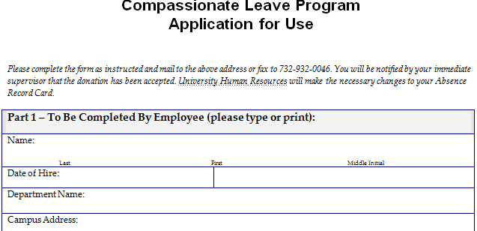
- Submit the completed form to your supervisor for review and sign-off. Donated leave time must be requested in advance and time will not be granted retroactively. You must apply as soon as you that you have a need for donated leave.
- University Human Resources will notify the supervisor would be notified of the determination and the supervisor will notify you.

Additional days may be requested, but with the maximum of 30 donated leave days per fiscal year.

Any unused donated leave time will be returned to the donated leave bank. Your supervisor should notify UHR.

Granted Compassionate Leave days are charged to the employees’ department, therefore, if the employee is on leave without pay when the request is approved, the department should return the employee to pay status by selecting the action “Paid Leave of Absence” in the Human Capital Management system.

For additional information, please contact the University Human Resources Benefits Office at 848-932-3990 visit: http://uhr.rutgers.edu/benefits/paid-time/compassionate-leave-program.

